**1.Write a program to Print Fibonacci Series using recursion.**

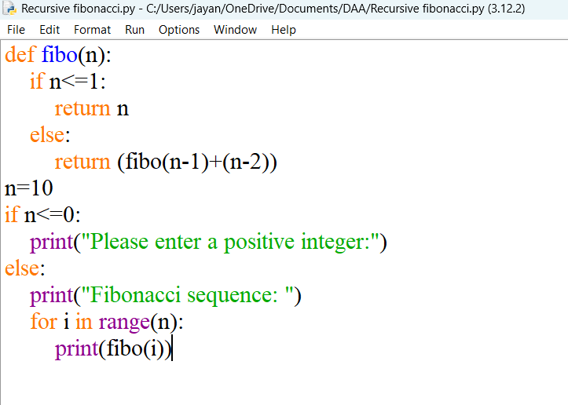

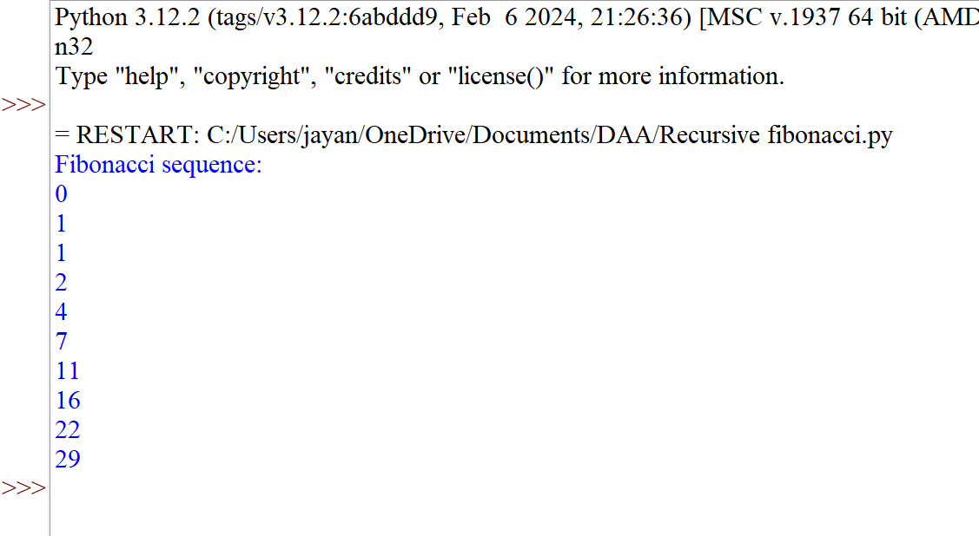

**2. Write a program to check the given no is Armstrong or not using recursive function.**

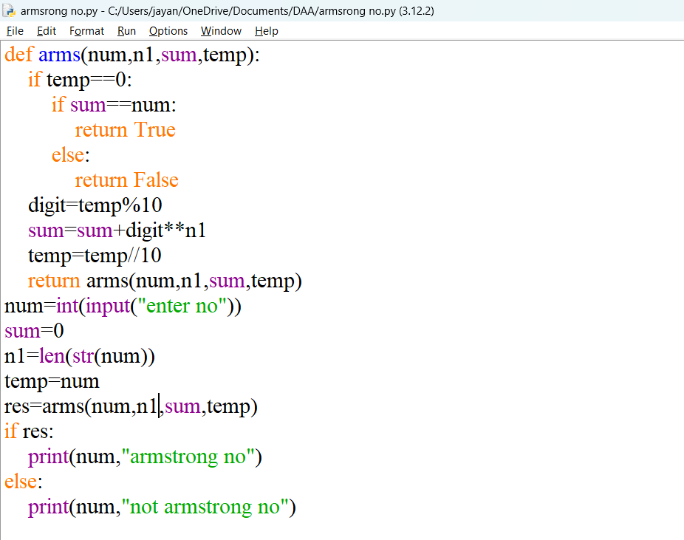

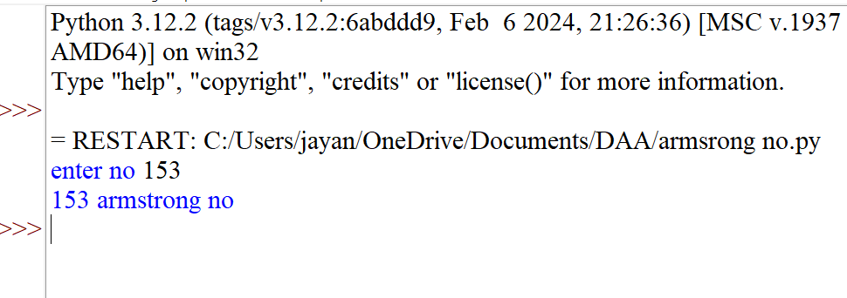

**3. Write a program to find the GCD of two numbers using recursive factorization**

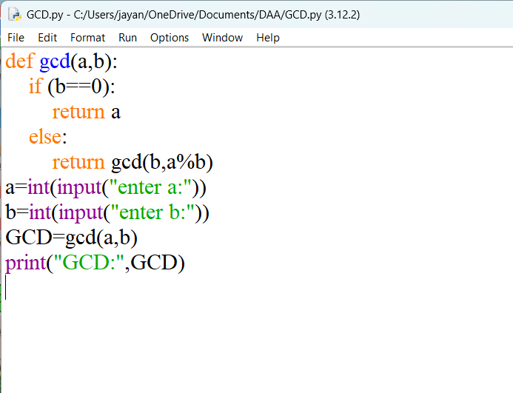

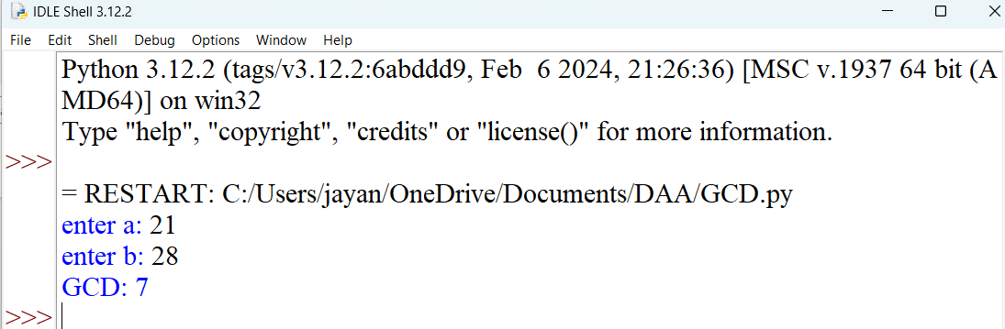

**4. Write a program to get the largest element of an array.**

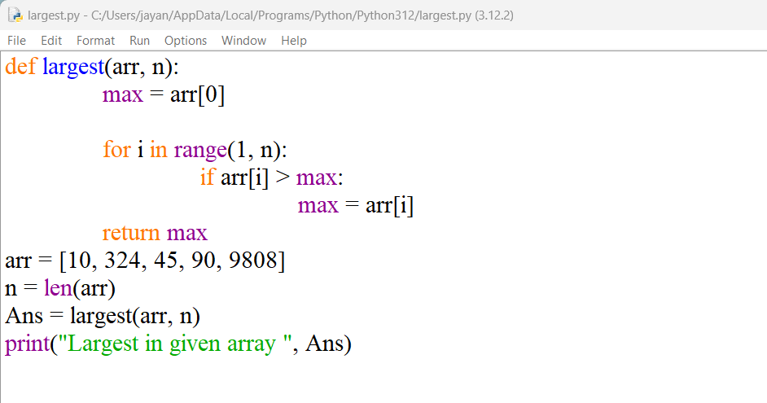

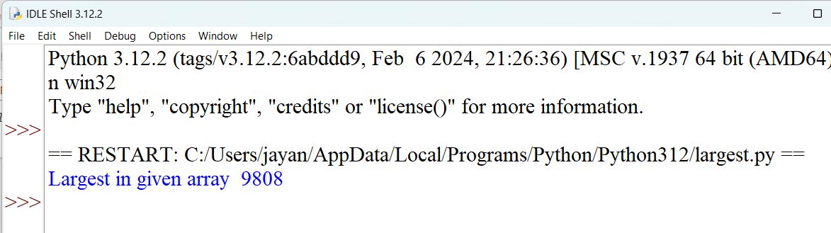

**5. Write a program to find the Factorial of a number using recursion.**

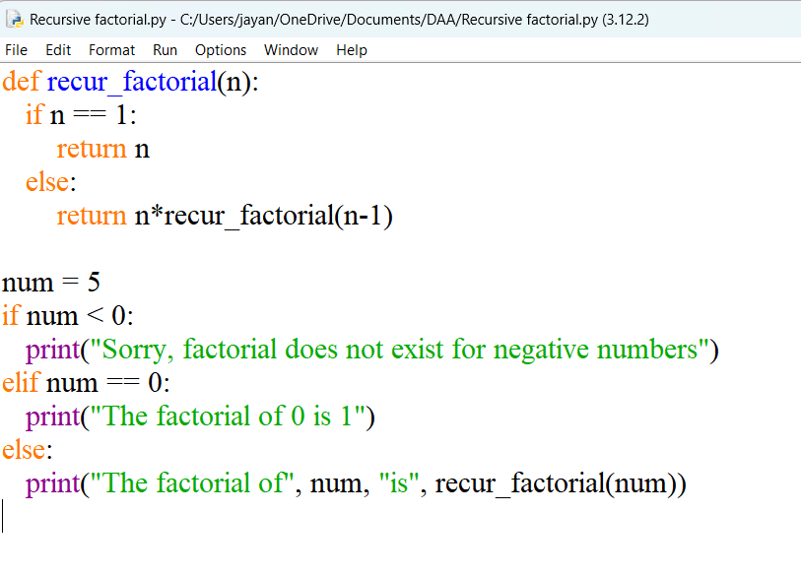

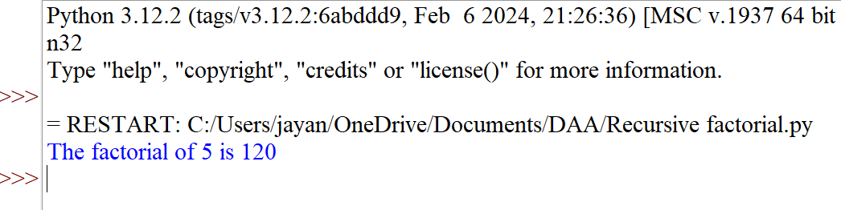

**6. Write a program to copy one string from another string using recursion.**

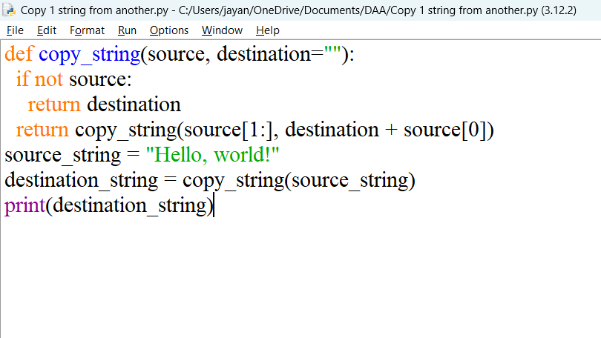

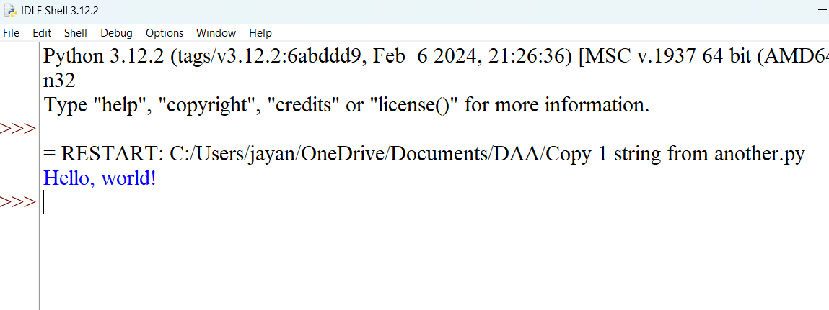

**7. Write a program to print the reverse of a string using recursion.**

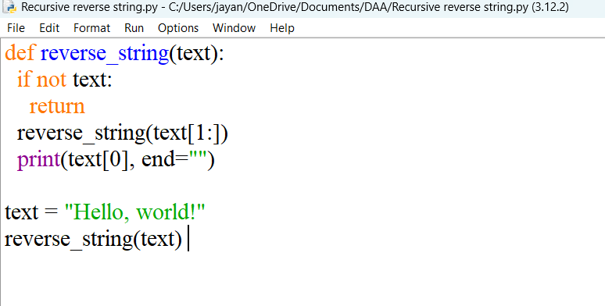

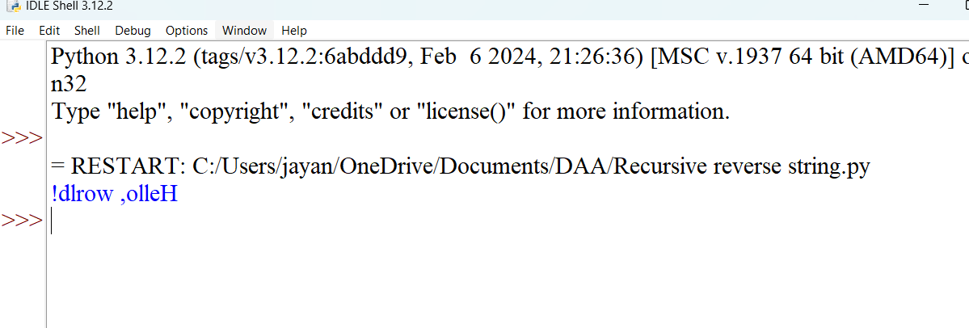

**8. Write a program to generate all the prime numbers using recursion.**

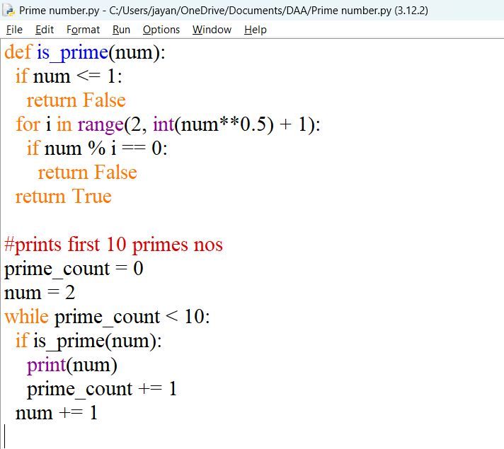

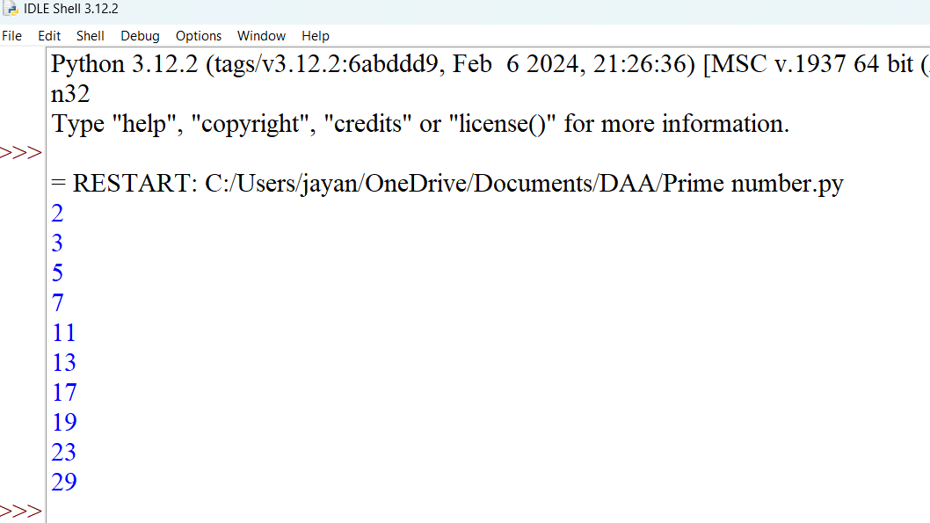

9.Write a program to check a number is a prime number or not using recursion.

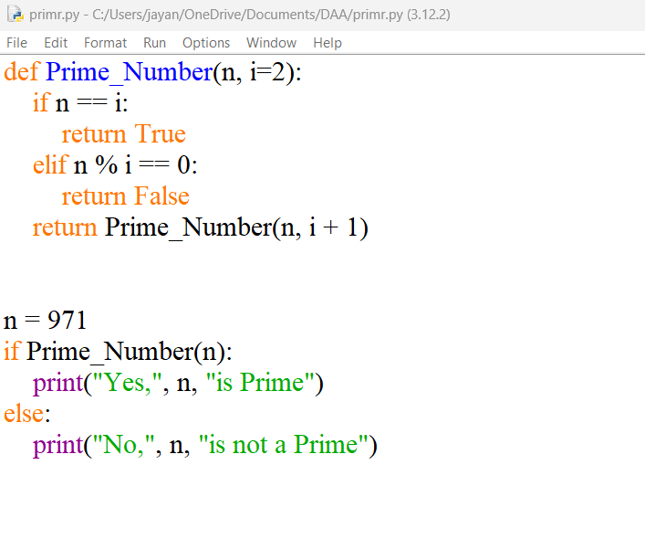

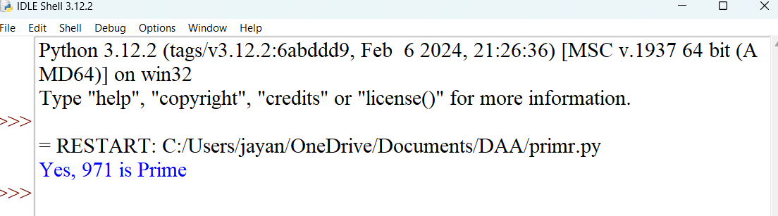

10.Write a program for to check whether a given String is Palindrome or not using recursion

